MACHINE LEARNING AND DEEP LEARNING EXTERNSHIP PROJECT REPORT

Team no: VIT-034 Team name: Amigos

**Project Title :**

**Predictive Maintenance Of Engines Using ML**

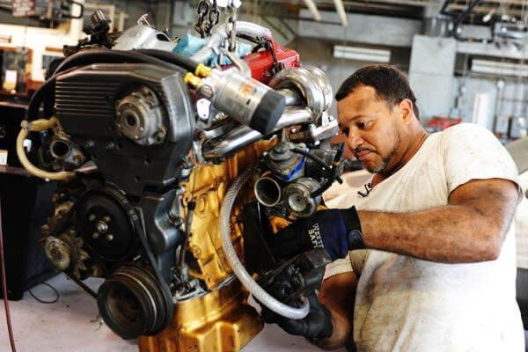

**DONE BY: Prince . A-18BEC7022**

**Shivani Manimaran -19BAI1135 Akhil Nambiar -19BEC1139 Tushar Singh-19BEC1256**

|  |  |  |
| --- | --- | --- |
| 1) INTRODUCTION | **CONTENT** |  |
| a) Overview | ..……………….. | **3** |
| b) Purpose | …………………. | **3** |

1. Literature survey …………………. **3**
2. Theoretical Analysis
   1. Block Diagram …………………. 4
   2. Hardware/Software designing …... **5**

c)

1. Experimental investigations…………… **6**

|  |  |  |
| --- | --- | --- |
| 5) Flowchart | ………………………. | **7** |
| 6) Result | ………………………….. | **7** |
| 7) Advantages and disadvantages …………………. **10** | | |
| 8) Conclusion | …………………….. | **10** |
| 9) FutureScope | ………………………. | **11** |
| 10) Bibliography | ………………………… | **11** |

1. **Introduction**

a.Overview:

# Predictive maintenance focuses on the organization of maintenance actions according to the actual health state of the system, aiming at giving a precise indication of when a maintenance intervention will be necessary

In the aviation industry for instance, there is a large amount of information and maintenance data that could be used to obtain meaningful results in forecasting

future actions. This study aims to introduce machine learning to predict failures of aircraft systems.

Accurate prediction of possible failures will increase the reliability of aircraft components and systems. The scheduling of maintenance operations help determine the overall maintenance and overhaul costs of aircraft components. Maintenance costs constitute a significant portion of the total operating expenditure of aircraft systems.

b.Purpose:

Predictive maintenance, as the name suggests, uses some parameters which are

measured while the equipment is in operation to guess when failures might happen. It intends to interfere with the system before faults occur and help reduce the number of unexpected failures by providing the maintenance personnel with more reliable scheduling options for preventive maintenance. It focuses on the organization of

maintenance actions according to the actual health state of the system, giving a precise indication of when a maintenance intervention will be necessary. The project aims to predict the failure of an engine by using Machine Learning to help improving productivity.

1. **Literature survey:**

By looking at the number of documents that are published over the years, between 2010 and 2020 it is confirmed that just recently (i.e., from the last three years) ML techniques in PdM captivates the attention of the researchers. As there are very few papers published in 2010 and 2011 in comparison to how the number of published articles just spiked-up through the year 2017–2018. Thus, it can be concluded that application of ML technique in the field of PdM is a new method with a growing interest in the field of research. This might be due to the increase in the amount of dataset that are generated in industries, by the industrial equipment, system, or components, and at the same time it could be due to the recent advances of ML techniques and their algorithms.

## Theoretical Analysis:

* 1. Block diagram:

The following is the block diagram of our proposed solution of using the Artificial Neural Networks to analyse the given id, settings and sensor readings of the aircraft engines to predict the time-of-failure of the engine and gives an alert if the engine is going to fail within the next 30 days.

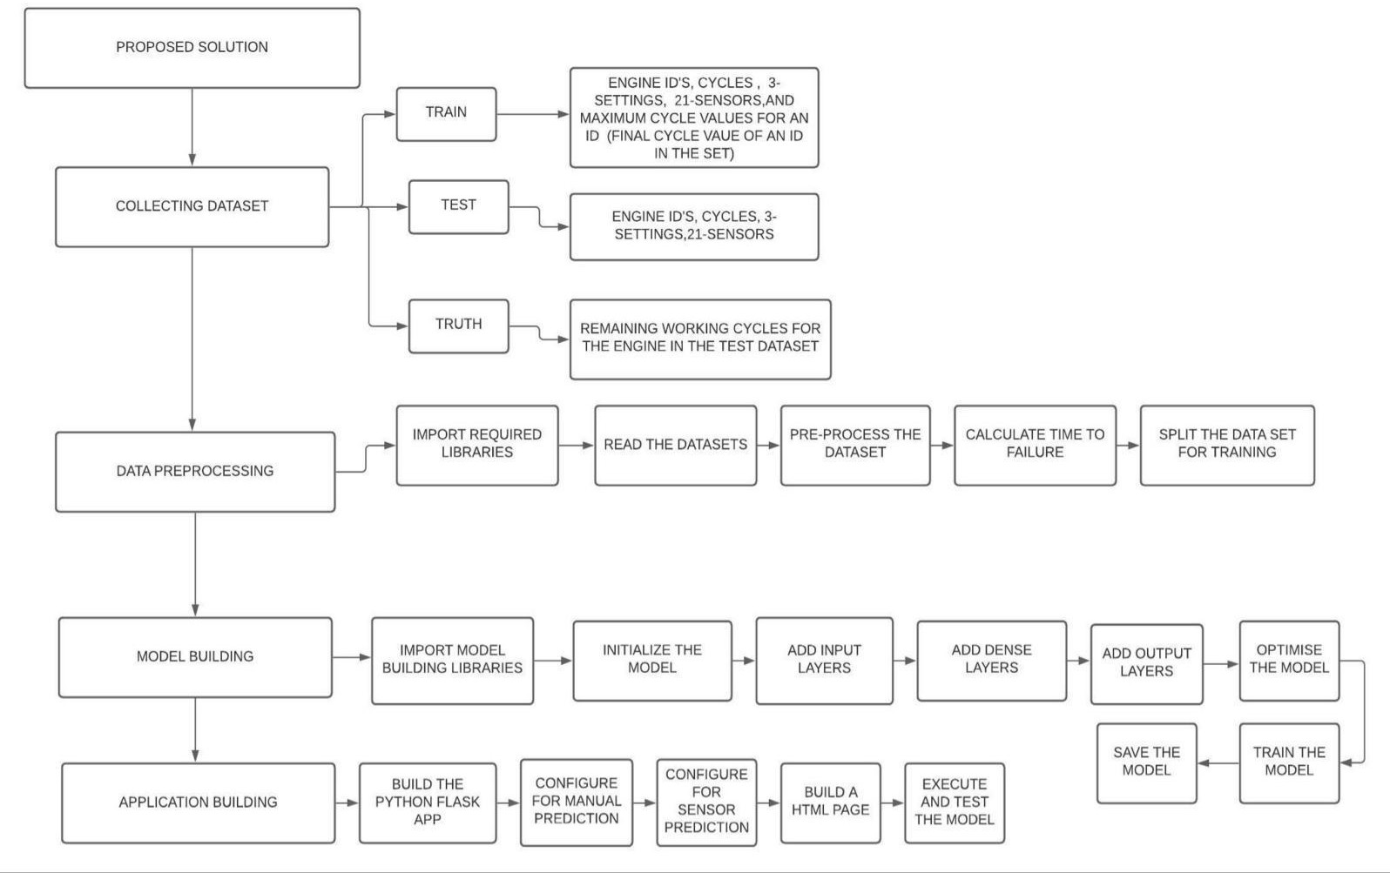

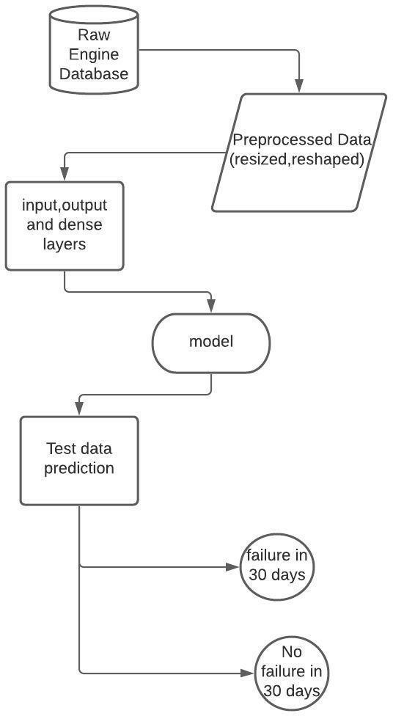

* 1. Hardware/software designing :

Hardware requirements : PC/Laptop

Software requirements: Python - 3.6, Keras - 2.2.4, Tensorflow

-1.13.0,spyder - 5, Jupiter Notebook

## Experimental Investigations :

Data sets consist of multiple multivariate time series.Each data set is further divided into training and test subjects.Each time series is from a different engine i.e., the data can be considered to be from a fleet of engines of the same type. Each engine starts with different degrees of initial wear and manufacturing variation which is unknown to the user. This wear and variation is considered normal, i.e., it is not considered a fault condition.

There are three operational settings that have a substantial effect on engine performance. These settings are also included in the data. The data is contaminated with sensor noise.The engine is operating normally at the start of each time series, and develops a fault at some point during the series. In the training set, the fault grows in magnitude until system failure. In the test set, the time series ends some time prior to system failure. The objective of the competition is to predict the number of remaining operational cycles before failure in the test set, i.e., the number of operational cycles after the last cycle that the engine will continue to operate. Also provided a vector of true Remaining Useful Life (RUL) values for the test data.The data were provided as a zip-compressed text file with 26 columns of numbers, separated by spaces. Each row is a snapshot of data taken during a single operational cycle, each column is a different variable. The columns correspond to:

1. Engine id
2. times, in cycles 3)operational setting 1 4)operational setting 2 5)operational setting 3 6)sensor measurement 1 7)sensor measurement 2

…………

26)sensor measurement 21

## Flowchart :

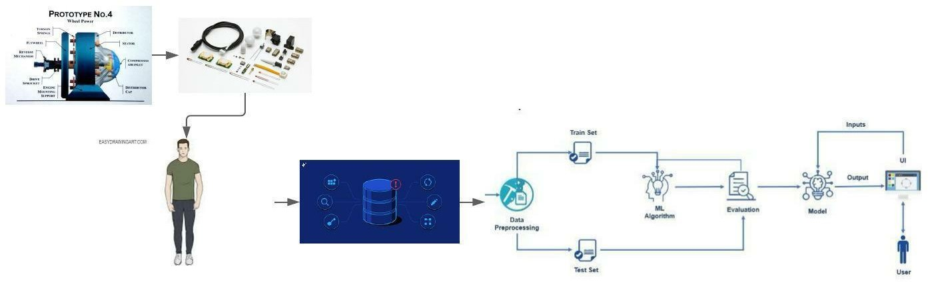

1. **Result :**

The following images show the screenshots of our web application of the Engine Failure Prediction using ML.

## I ) Sensor prediction:

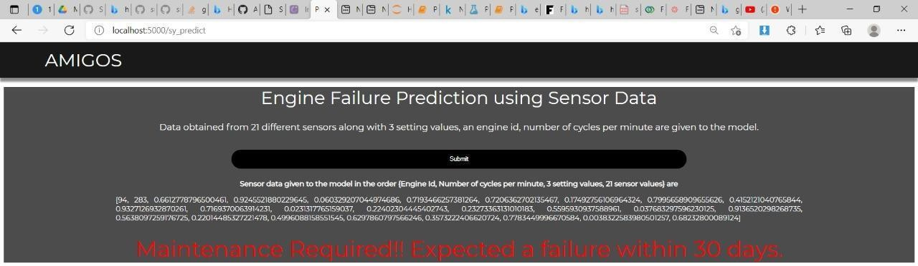

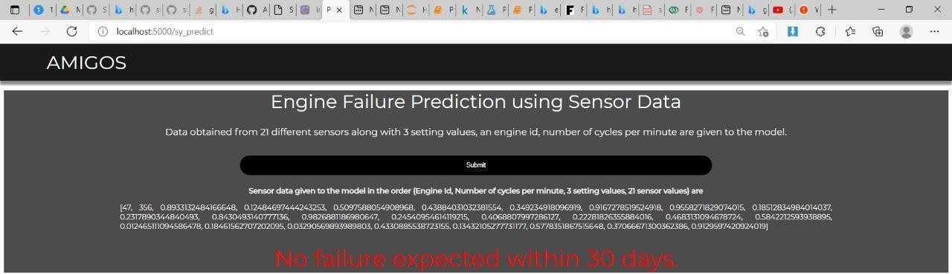

**II) Manual Prediction :**



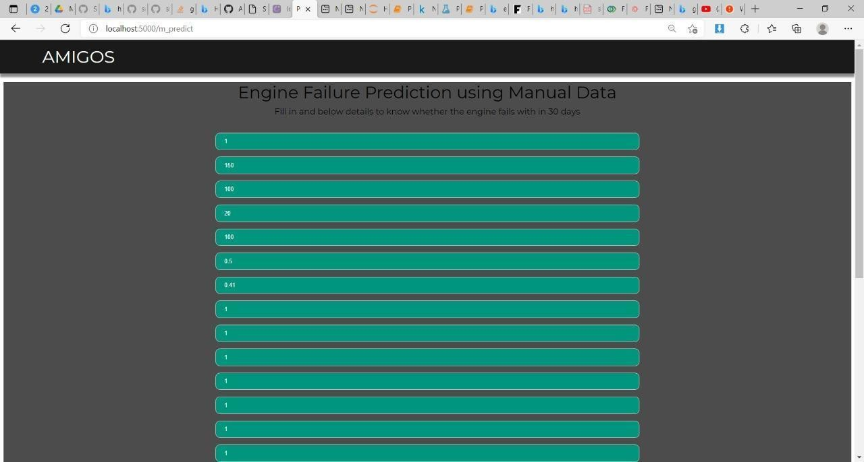

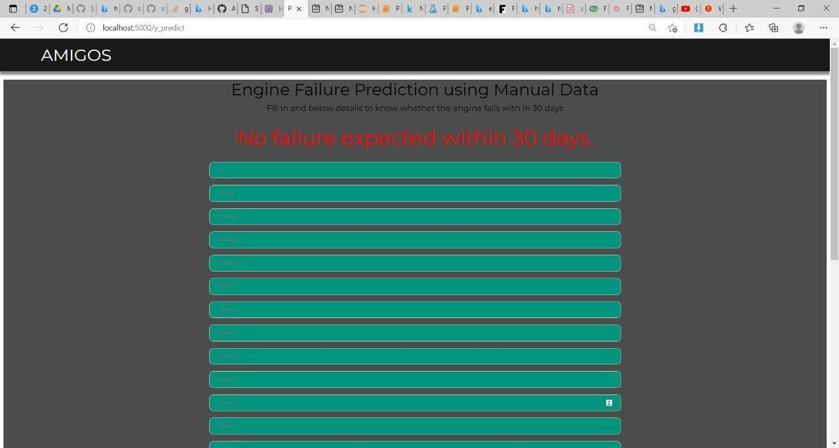

1. **Advantages & Disadvantages :**
2. **Advantage :**
   * Compared with preventive maintenance ,predictive maintenance ensures that a piece of equipment requiring maintenance is only shut down right before imminent failure.
   * This reduces the total time and cost spent maintaining equipment.

## Disadvantage :

* + Compared with preventive maintenance, the cost of the condition monitoring equipment needed for predictive maintenance is often high.
  + The skill level and experience required to accurately interpret condition monitoring data is also high.

## Conclusion :

The main objective of predictive maintenance is to predict when equipment failures can occur. Then prevent the failure by taking relevant actions. Predictive maintenance system monitors future failures and will schedule maintenance in advance. Like in our model it predicts 30 days early.

This results in several cost savings :

* Reduces the frequency of maintenance.
* Minimizes the time spent on a particular equipment being maintained and allows that time to be productive.
* Minimizes the cost of maintenance.

## Futurescope:

We have calculated time to failure with the given datasets and labeled the maintenance according to it . It may be wrong to some extent.In future we can develop a regression model which predicts the ttf first and then does the binary classification of maintenance.

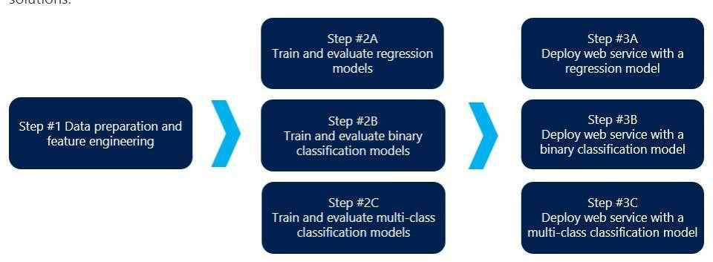

## Bibliography :

[**https://www.kaggle.com/behrad3d/nasa-cmaps**](https://www.kaggle.com/behrad3d/nasa-cmaps)

[**Machine Learning Techniques for Predictive Maintenance (infoq.com)**](https://www.infoq.com/articles/machine-learning-techniques-predictive-maintenance/)

[**Failure Prediction Machine Learning: Using Machine Learning to Find Failures Before**](https://www.onupkeep.com/answers/predictive-maintenance/machine-learning-to-find-failures)

[**They Occur (onupkeep.com)**](https://www.onupkeep.com/answers/predictive-maintenance/machine-learning-to-find-failures)

[**Predictive Maintenance: Step 1 of 3, data preparation and feature engineering | Azure**](https://gallery.azure.ai/Experiment/Predictive-Maintenance-Step-1-of-3-data-preparation-and-feature-engineering-2)

[**AI Gallery**](https://gallery.azure.ai/Experiment/Predictive-Maintenance-Step-1-of-3-data-preparation-and-feature-engineering-2)